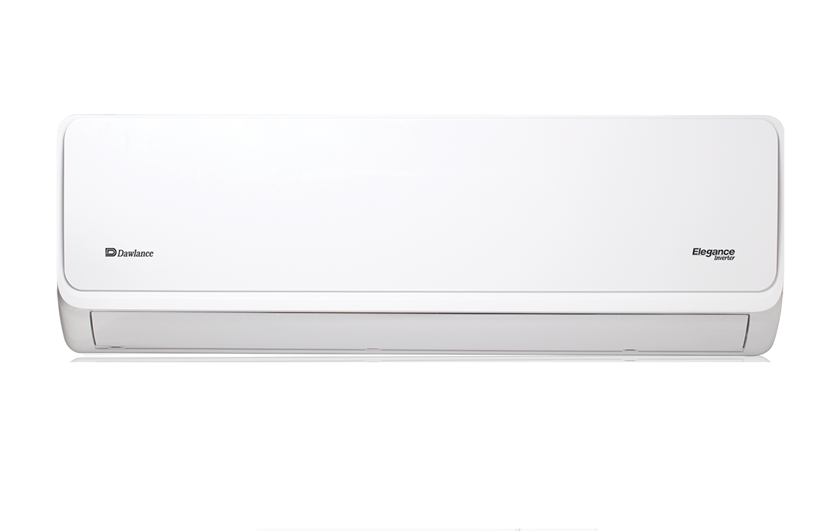

Elegance Inverter

Dawlance Elegance Inverter Series with Its Golden Fins

**Rs:84,500.00**